

|  |
| --- |
| Misys |
| Trading Hours in Asian Future Markets |
| FusionInvest Toolkit |

|  |
| --- |
| Su, Yuanjia |



Contents

Document Control 2

Functional details 3

1.1 Business requirement 3

Technical details 3

2.1 List of Asian Markets 3

2.2 Order WF Activity 3

2.3 Current local time 4

2.4 Order property and execution time 4

2.5 Trade date 4

**© Misys Limited   
All rights reserved**

**Registered in   
England & Wales**

No. 01360027

**Registered Office:**One Kingdom Street Paddington   
London W2 6BL  
United Kingdom

Document Control

|  |  |  |  |  |
| --- | --- | --- | --- | --- |
| ACTION | VERSION | NAME | DATE | COMMENTS |
| Creation | 0.01 | Yuanjia Su | 12-SEPT-2016 | Beta version, internal distribution |

Functional details

1.1 Business requirement

Asian Future markets have different trading hours, for instance pit trading in Singapore Exchange is between 07:30 and 14:25, and Korea Exchange is from 09:00 to15:45. Orders that are not executed in the pit are executed in the electronic markets which open normally 1 hour after the pit is closed.

Mediolanum would like to flag the orders that are executed if it’s after the pit session, and change the trade date to D+1.

For example: we trade an Asian future today (04/08/16) at 10.30 am – which is outside of Singapore trading session – it is routed to EMSX and executed today (04/08/16) for trade date tomorrow (05/08/16).

Execution date = (04/08/16)

We need to send it to the clearer on (05/08/16) with trade date = (05/08/16)

Technical details

2.1 Prerequisites

1) Asian Futures Exchanges

Mediolanum provided a list of Asian markets with the Pit/Electronic trading hours:



In FusionInvest, we will manage only the closing time (in time zone of the exchange) in the market external references tab, the property is populated by the following SQL script:

insert into EXTRNL_REF_MARKET_DEFINITION values((select max(ref_ident)+1 from EXTRNL_REF_MARKET_DEFINITION), 'Pit closing time (local)');

2) Windows time zones

The corresponding time zone of the market is also mandatory to be added in the external references:

insert into EXTRNL_REF_MARKET_DEFINITION values((select max(ref_ident)+1 from EXTRNL_REF_MARKET_DEFINITION), 'Timezone');

The time zone name convention should follow Microsoft Time Zone Index Values which can be found here:

<https://msdn.microsoft.com/en-us/library/ms912391(v=winembedded.11).aspx>

Or the StandardName column in this file:



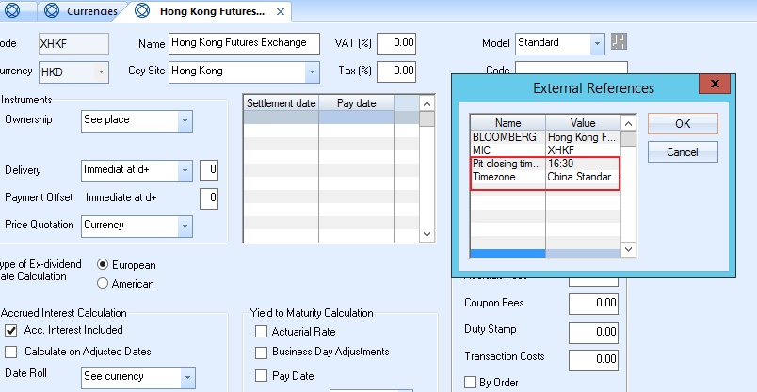

2.2 Order WF Activity

In the Order Workflow, there will be an activity to differentiate the instrument type and the market.

1. This toolkit concerns about **only the futures**, so the filter condition is instrument type = ‘F’
2. If a new market is traded, user will only have to make sure the “Pit closing time” is not empty and the “Timezone” is set up correctly

If the above conditions are matched, the toolkit will check the local time of the market against the pit closing time.

2.4 Order property and execution time

An order property (suggest name: “Asian outside PIT”) will be added by the SQL script:

insert into ORDER_PROPERTY (ID,NAME,CATEGORY,DATATYPE,VISIBILITY) values (nvl((select max(id)+1 from ORDER_PROPERTY),1),' Asian_outside_PIT','Toolkit','System.Boolean',1);

The same property should be added to the execution:

insert into EXEC_PROPERTY(PROPERTYID,NAME,CATEGORY,DATATYPE,TYPE,VISIBILITY) values (nvl((select max(PROPERTYID)+1 from EXEC_PROPERTY),1),' Asian_outside_PIT','Toolkit','System.Boolean',2,1);

If an order is “Filled”, the WF will compare the execution local time with the pit closing time, and flag if the execution time is later.

Note: for the same order, we can have some partial fills within the pit session and some outside the session. So the same order can generate trades for today and for tomorrow.

2.5 Trade date

A toolkit transaction dialog will be created, and has the same property “Asian_outside_PIT”, in order to transfer the order flag to trades (loaded at transaction server level).

A transaction creation toolkit will take care of changing the trade date to D+1 if the property has been set to true.

Sign-off

|  |  |  |  |
| --- | --- | --- | --- |
| *Date* |  | *Date* |  |
| *Authorized Mediolanum Signature(s)* |  | *Authorized MISYS Signature(s)* |  |

